IVY TECH COMMUNITY COLLEGE
SDEV 140 / Introduction to Software Development
Software Development Project – Part 1

INTRODUCTION: Over the next two-three weeks, you will develop a small software project that includes a wide range of activities: needs analysis, screen design, algorithm development, programming, testing, debugging, documentation and publishing.

PRELIMINARY: You should already have accessed and installed PySide6 for Qt development in Python.

The last part of the lab assignment is to complete the design of the DroneDogs Order Form below by entering names for the controls on the screen form, using standard Python naming conventions (as discussed in class).

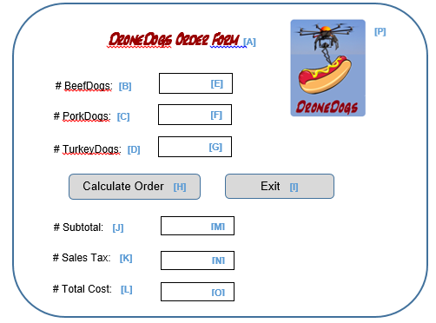

- Enter the control name you would assign for each control (widget):

A: LabelTitle

B: LabelBeefDogs

C: LabelPorkDogs

D: LabelTurkeyDogs

E: SpinBoxBeefDogs

F: SpinBoxPorkDogs

G: SpinBoxTurkeyDogs

H: PushButtonCalcOrder

I: PushButtonExit

J: LabelSubtotal

K: LabelSalesTax

L: LabelTotalCost

M: LineEditSubtotal

N: LineEditSalesTax

O: LineEditTotalCost

P: LabelLogo

- Which control would you recommend have the default “focus” (the cursor is active here) when the form loads?

I would recommend the focus to be the first input the user interacts with, so the Beef Dogs input field. This way the user can just start their order without clicking, and then they can just tab through the fields.

- Would you design your application so that the Enter Key on the keyboard automatically worked as a click on the Calculate Order button? The Exit button? Neither? Why?
I would go with having the enter key as a click on the calculate order button, this way the user can calculate the order without having to touch the mouse. Using the enter key to exit could lead to closing the program on accident, which would be annoying and not nearly as helpful as the calculate order.

